Design Notes

Overview

Part III extends the Part II simulator with a TRAP code implementation, and the ability to run Program 2 (read a paragraph, input a search word, find and print the occurrence of the word). We also expanded the UI to show compact output of the word in proper format.

Project: CS6461 Computer Architecture Simulator
Component: Part III – TRAP Code, Program 2 Execution
Language: Java (JDK 8 compatible)
Packages: src.main.java.core, src.main.java.core.cache, src.main.java.ui
Entry Point: src.main.java.ui.SimulatorUI

High Level Architecture
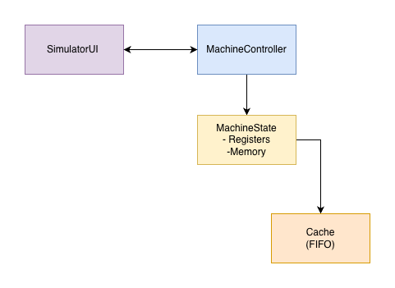
Responsibilities
- SimulatorUI: front panel, register/memory visualization, file-based IPL, console I/O, cache visualization (lines + stats).
- MachineController: decodes UI actions, orchestrates fetch/decode/execute via MachineState, mediates stepping vs. run.
- MachineState: holds architectural state (GPRs, IXRs, PC, MAR, MBR, IR, CC, MFR), memory array, and Cache. Implements instruction semantics and EA computation.
- Cache: fully associative, 16-line, 1-word blocks, FIFO replacement, write-through, write-allocate. Exposes readWord/writeWord, statistics, and snapshot() for UI.

ISA Compliance and Addressing
- Word size: 16 bits.
- Address space: 12-bit (0–4095). PC/MAR displayed as 4-digit octal; 16-bit registers as 6-digit octal.
- Addressing modes supported: Direct, Indexed (X1–X3), Indirect bit I as per ISA. Effective address (EA) derived in MachineState before memory access.
- Assembler interaction: Not required at runtime for Part II. IPL loads machine code from file selected in UI.
Validation choices
- Instruction handlers validate register indices, IX values, and ensure final EA ∈ [0,4095].
- Arithmetic/logic set CC bits according to the ISA (overflow, underflow, equal/zero, greater/less where applicable).

Memory & Caching

Memory
- Implemented as int[] memory within MachineState (16-bit masked on store/load).
- Direct access APIs (bypass cache) for internal cache write-through:
  - getMemoryDirect(int address)
  - setMemoryDirect(int address, int value)
- Cached access APIs used by instruction execution:
  - getMemory(int address) → cache.readWord(address)
  - setMemory(int address, int value) → cache.writeWord(address, value)

Cache
- Associativity: Fully associative
- Lines: 16
- Block size: 1 word (no sub-block)
- Replacement: FIFO pointer advances on every allocation
- Write policy: Write-through
- Allocation: Write-allocate
Data structures (src.main.java.core.cache.Cache)
- CacheLine { boolean valid; int tag; int data; }
- Cache members: CacheLine[] lines, int fifoPointer, AccessKind, last access index, hit/miss counters.
- Public APIs:
  - int readWord(int address)
  - void writeWord(int address, int value)
  - String getCacheStateString() (plain text table)
  - Snapshot snapshot() and statistics getters for UI rendering
Correctness notes
- Tag = full physical address because block size = 1 and cache is fully associative.
- All external memory accesses route through Cache (except *Direct APIs for internal write-through).
- UI uses snapshot() to highlight last access and show FIFO pointer.

Instruction Coverage (Part II)
Implemented: All ISA operations required through Part III (Load/Store, Transfer, Arithmetic/Logic, Shifts/Rotates, Immediate/Reg-to-Reg forms, Jumps/Branches, I/O) with correct CC updates and TRAP Execution.
Deferred to Part IV: Floating Point ops, Vector ops

I/O & IPL
- Console input: Text typed in the UI field is enqueued into the controller; machine reads via IN devid (keyboard device ID 0).
- Console output: OUT to printer device appends to the Printer text area.
- Compact Output: Refresh output to see clear readable results.
- IPL: UI prompts for a machine-code file (octal words); controller loads words to memory and sets PC to first instruction.
TRAP Code Table
Trap Code | Meaning | Description
0001 (1) | OUT (Printer) | Outputs the character in GPR[R] to device 1.
0010 (2) | IN (Keyboard) | Reads one character from console input into GPR[R].
0011 (3) | OUT Newline | Convenience routine that outputs '\n'.
1111 (15) | HALT | Terminates the program execution.
(Other codes reserved for future expansion.)
TRAP Execution Flow
- MachineState fetches TRAP instruction and extracts the 4-bit trap code.
- Control transfers to MachineController.handleTRAP().
- The controller dispatches to the specific OS routine:
- OUT: read GPR register → append char to Printer text area.
- IN: wait for UI input buffer → store value into GPR.
4. UI is updated to reflect device activity (Printer log + Compact Output).
5. Control returns to MachineState, PC increments, and normal execution continues.

UI Enhancements (Part II)
- Cache Panel:
  - Monospaced grid of lines with green highlight for hit and soft red for miss on the last access.
  - Stats: Total Hits/Misses and split by Reads/Writes.
- Register block: PC/MAR (4-digit octal), MBR/IR (6-digit octal), CC/MFR (4-digit octal).
- Input helpers: Octal ↔ Binary conversion field (for debugging loads/stores), small square load buttons next to registers.
- ADDED Compact Output: to visualize the word/ sentence occurrence for P2.

Testing Strategy & Evidence

Unit-style micro tests (manual via UI)
- Load/Store addressing modes: For X=0..3, I∈{0,1}, addresses near 0 and near 4095.
- Arithmetic: AIR/SIR edge cases (±1 around 0x0000/0xFFFF), signed comparisons in branches.
- Shifts/Rotates: Left/right with varying counts, verify bit loss and sign rules.
- Jumps/Branches: Taken vs. not-taken, indirect targets.
- I/O: IN (keyboard), OUT (printer).

Cache validation
- Compulsory misses: Reading 16 unique addresses → 16 misses.
- FIFO behavior: Access 17th unique address → evicts line 0.
- Write-through: Store then read via getMemoryDirect → values match.
- Write-allocate: Store to a cold line → line populated, subsequent read hits.

Program 2 run (end-to-end)
Program 2 Processing Flow
- Display the paragraph using TRAP 1 output.
- Prompt the user: "Enter word:".
- Wait for keyboard input via TRAP 2 until newline detected.
- Tokenize the paragraph by:
  - Counting sentences based on '.', '?', '!'.
  - Counting words between separators.
- Compare each paragraph word to the input word case-insensitively.
- When a match is found:
  - Output "Word: <w>"
  - Output "Sentence: <n>"
  - Output "Word: <position>"
- If no match is found:
  - Output "Not found".
- Program ends with TRAP 15 (HLT)
Steps:
- Load machine code file via IPL, run:
  - Program.txt file is already loaded with the following content:
Rain falls gently against the window. A gentle rain often brings peace, yet sometimes it hides a storm. The children watch the rain as it gathers into puddles that reflect the sky.
- Enter a word:
  - Enter existing word: window
- Output:
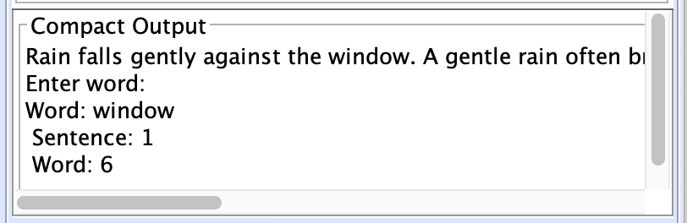

Artifacts recorded
Input:
Word: Rain
Output:
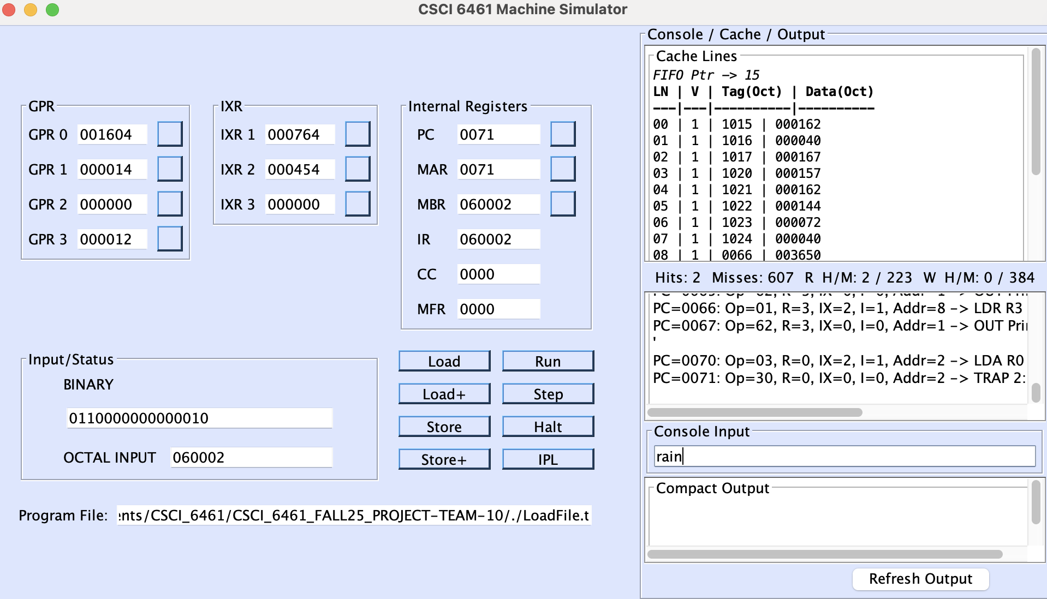
Upon clicking Refresh Output:
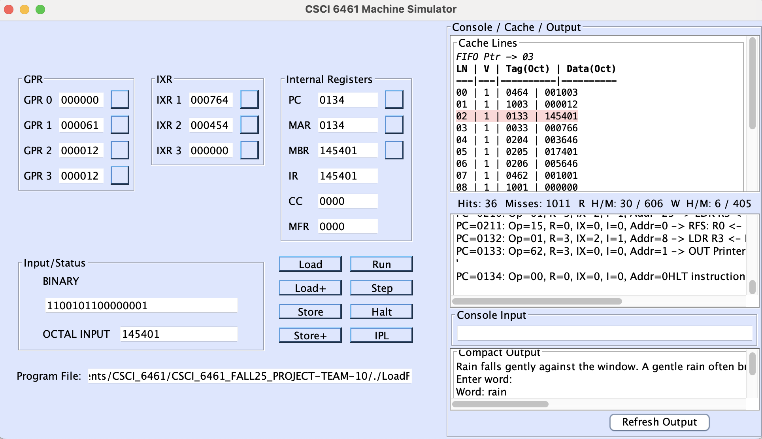
Rain falls gently against the window. A gentle rain often brings peace, yet sometimes it hides a storm. The children watch the rain as it gathers into puddles that reflect the sky.
Enter word:
Word: rain
Sentence: 1
Word: 1

More cases in P3 Documentation.

Error Handling & Faults
- Undefined opcode: Sets MFR code and halts or triggers a machine fault handler if enabled.
- Address out of range: Guarded in EA computation and memory access; MFR updated.
- I/O device not implemented: UI shows a descriptive message on the printer area.
- IPL parse errors: Clear message in printer area and no state change if file malformed.

